HTML - HyperText Markup Language  
  
is used to create docs on the web.  
  
  
SYNTAX  
 -tags , attributes , elements  
  
tags – opening and closing   
attributes – provide extra information about an element and are always specified in the opening tags.  
elements – is a tag wrap around the conent   
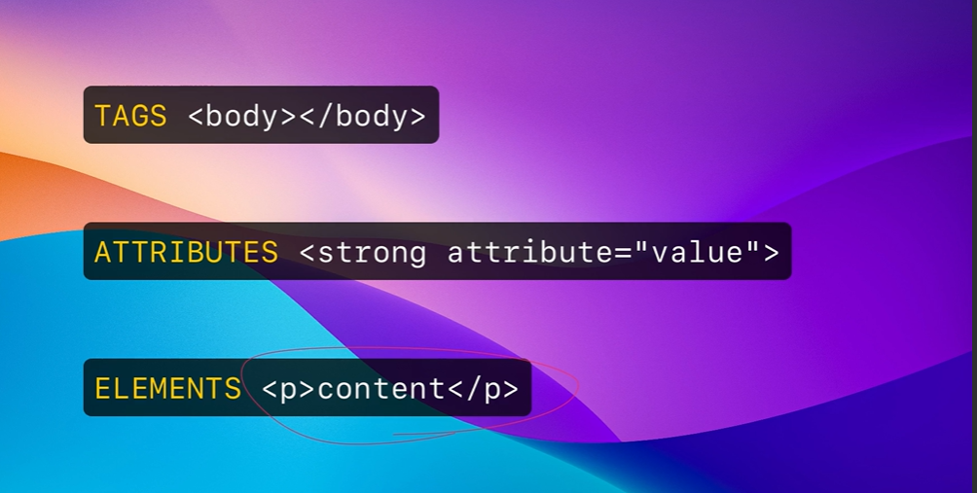

CSS – Cascading styles sheets  
  
create some sort of prestation or design style  
  
CSS – syntax   
style rule   
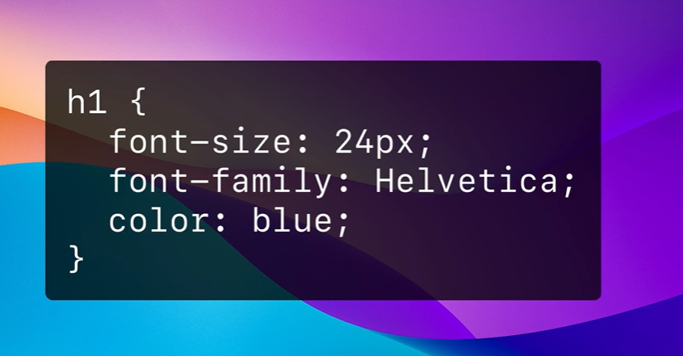  
  
  
H1 - SELECTOR   
# - ID’s  
. – Classes  
  
  
VACUBALRY -   
SELECTORS , PROPERTIES AND VALUE  
 SELECTORS – TO STYLE SPECIFIC OR MULTIPLE HTML ELEMENTS  
  
IN THE ABOVE PIC – h1 is the **selector**  
PROPERTIES – THIS ARE LOCATED INSIDE THE CURLY BRACKETS (FONT – SIZE , FONT-FAMILY AND COLOR)  
VALUE – WHAT IS ASSGINED TO THE PROPERTIES (24PX…..)  
  
  
  
**NAMING FILE AND FOLDERS:**

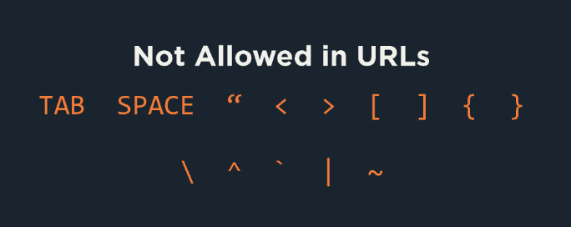

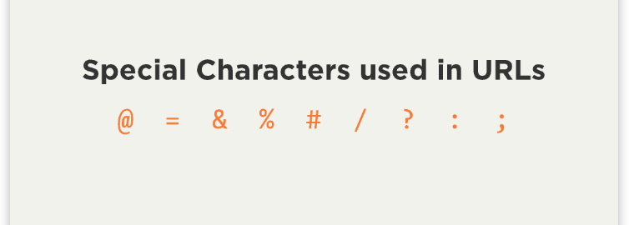

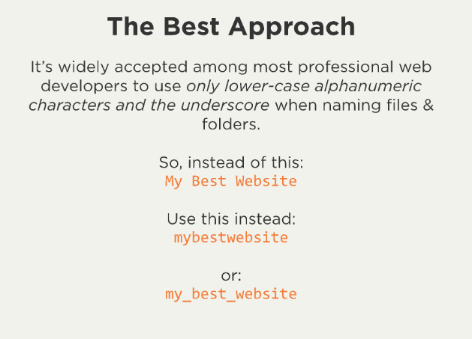  
  
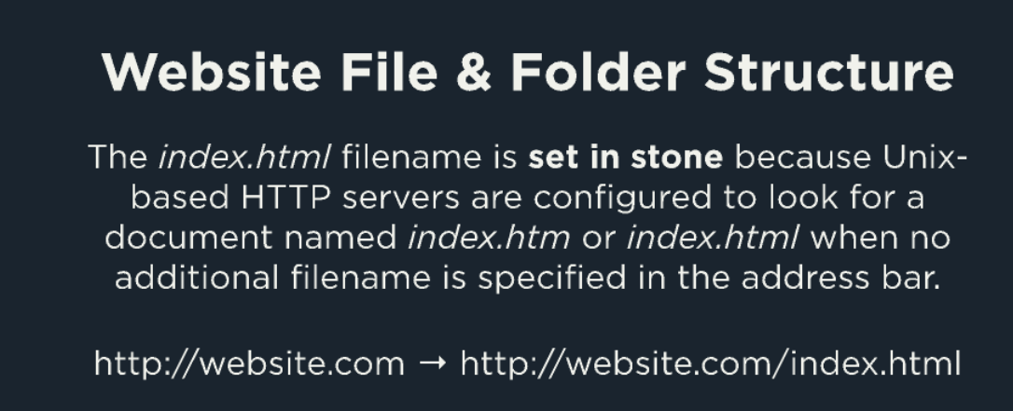

  
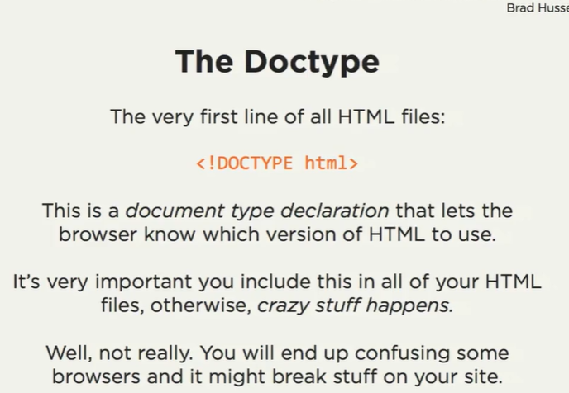

JAVA SCRIPT

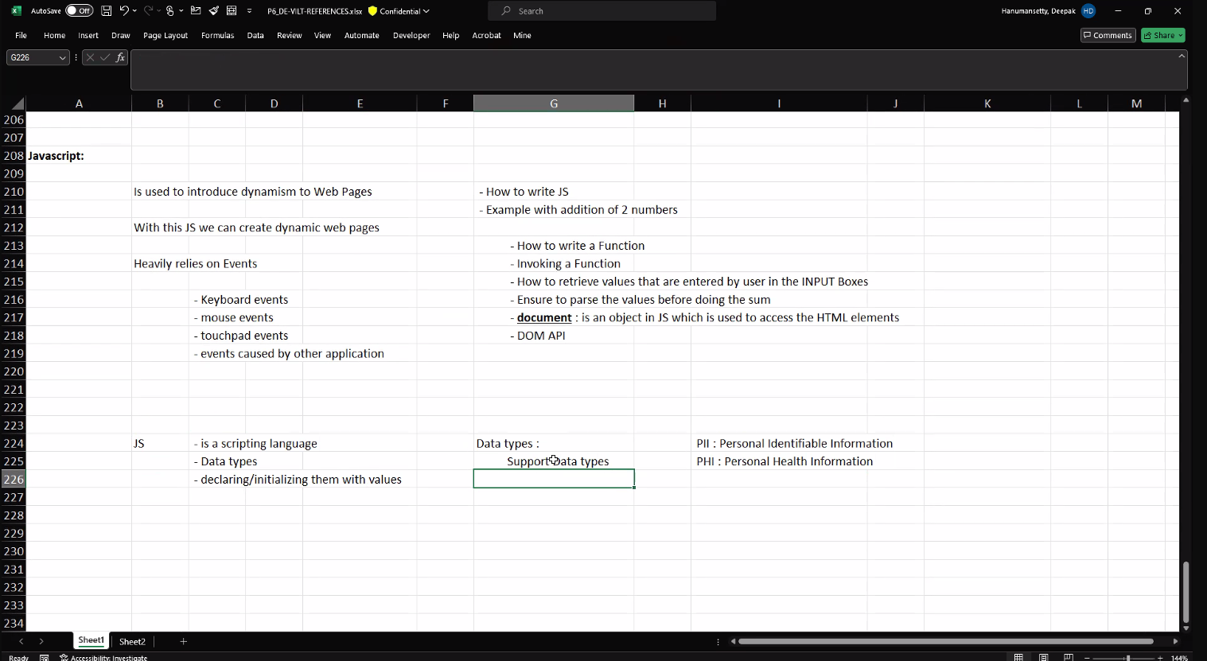

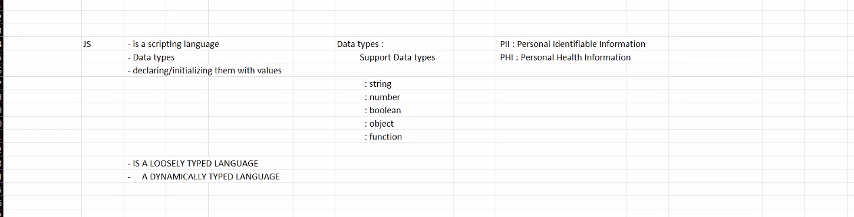

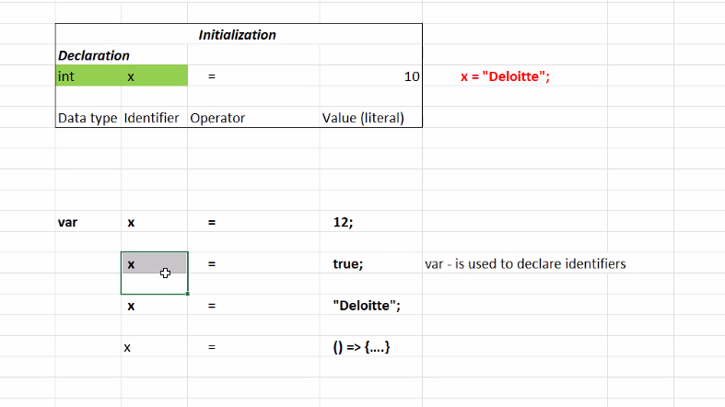

Can assign any datatype value to variable at any point of time.  
  
Type inference in JavaScript refers to the ability of the language (or its tools like TypeScript) to automatically deduce the type of a variable or expression without explicit type annotations.

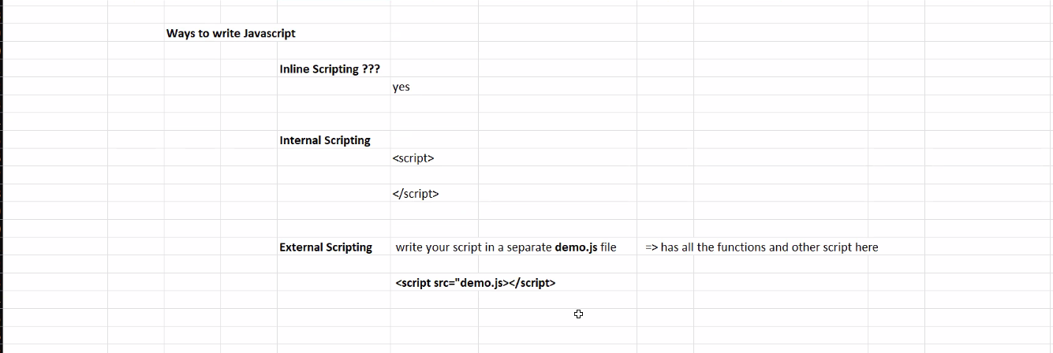

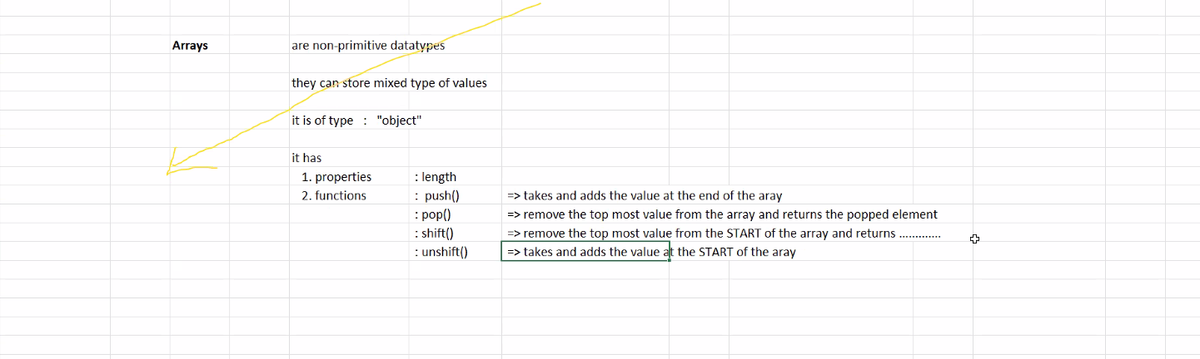

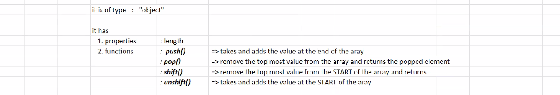

DOM – it is an hierarchical structure.   
  
  
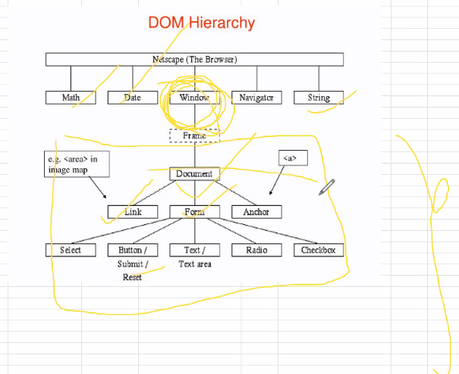

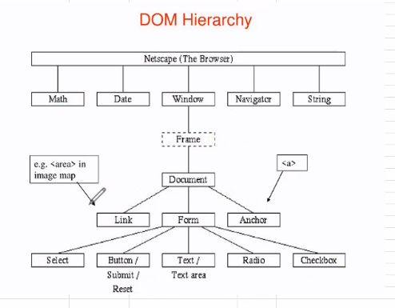

ECMA  
  
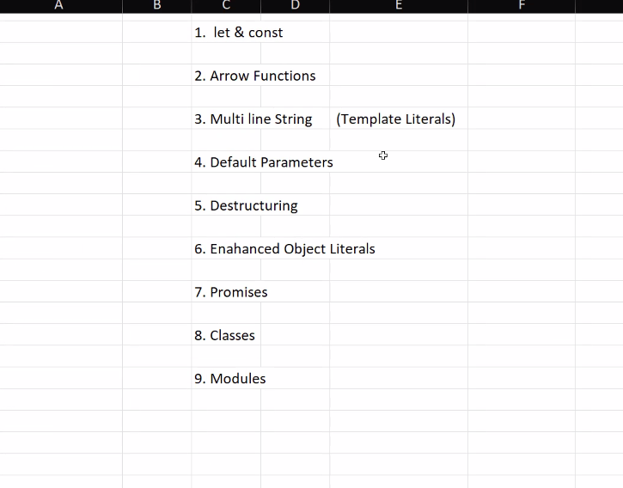

Typescript-

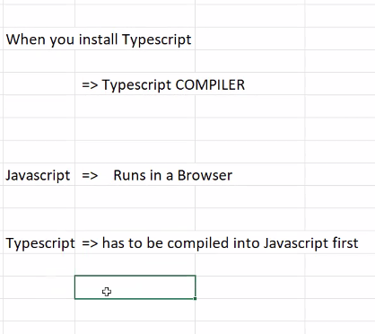

Typescript is a strictly typed language.

Transform the typscrit in js

Workarounds – take js property as well in ts.

JAVA –

